TREE ASSESSMENTS
Trees are assets to the community and deserve the best possible care. If you answered “yes” to any of the questions in the tree hazard checklist or see any of the defects contained in the illustrations, your tree should be examined by an ISA Certified Arborist.

Tree Hazard Checklist
These guidelines are set forth and developed by the International Society of Arboriculture (ISA).

GENERAL QUESTIONS | YES | NO | COMMENTS
Are there large dead branches in the tree?
Are there detached branches hanging in the tree?
Does the tree have cavities or rotten wood along the trunk or in major branches?
Are mushrooms present at the base of the tree?
Are there cracks or splits in the trunk or where branches are attached?
Have any branches fallen from the tree?
Have adjacent trees fallen over or died?
Has the trunk developed a strong lean?
Do many of the major branches arise from one point on the trunk?
Have the roots been broken off, injured, or damaged by lowering the soil level, installing pavement, repairing sidewalks, or digging trenches?
Has the site recently been changed by construction, raising the soil level, or installing lawns?
Have the leaves prematurely developed an unusual color or size?
Have trees in adjacent wooded areas been removed?
Has the tree been topped or otherwise heavily pruned?

Defects in Urban Trees

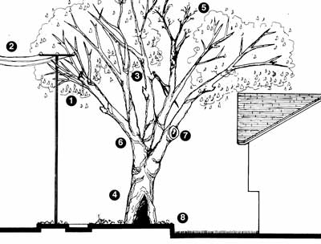
The following are defects or signs of possible defects in urban trees (see figure):
- Re-growth from topping, line clearance, or other pruning.
- Electrical line adjacent to tree.
- Broken or partially attached branch.
- Open cavity in trunk or branch.
- Dead or dying branches.
- Branches arising from a single point on the trunk.
- Decay and rot present in old wounds.
- Recent change in grade or soil level, or other construction.

Defects in Rural Trees

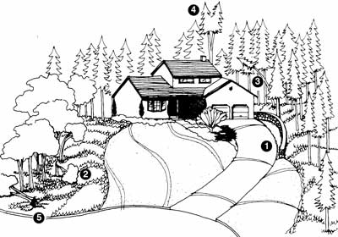
The following are defects or signs of possible defects in rural trees (see figure):
- Recent site construction, grading and tree removal, clearing of forests for development.
- Previous tree failures in the local area.
- Tree leaning near a target.
- Forked trunk; branches and stems equal in size.
- Wet areas with shallow soil.

Managing Tree Hazards
An arborist can help you manage the trees and can provide treatments that may help make your tree safer, reducing the risk associated with hazardous trees. An arborist familiar with hazard tree evaluation may suggest one or more of the following:
- Remove the target. While a home or a nearby power line cannot be moved, it is possible to move picnic tables, cars, landscape features, or other possible targets to prevent them from being hit by a falling tree.
- Prune the tree. Remove the defective branches of the tree. Because inappropriate pruning may weaken a tree, pruning work is best done by an ISA Certified Arborist. Proper pruning should follow the guidelines set forth in ANSI standards A300.
- Cable and brace the tree. Provide physical support for weak branches and stems to increase their strength and stability.
- Provide routine care. Mature trees need routine care in the form of water, fertilizer (in some cases), mulch, and pruning as dictated by the season and their structure.
- Remove the tree. Some hazardous trees are best removed. If possible, plant a new tree in an appropriate place as a replacement.
Recognizing and reducing tree hazards not only increases the safety of property and that of the community, but also improves the tree’s health and may increase its longevity!

HOW AND FREQUENCY FOR PRUNING OF TREES

How:
Crown Thinning: primarily for hardwoods, is the selective removal of branches to increase light penetration and air movement throughout the crown of a tree. The intent is to maintain or develop a tree's structure and form.

Crown raising: is the practice of removing branches from the bottom of the crown of a tree to provide clearance for pedestrians, vehicles, buildings, lines of site, or to develop a clear stem for timber production.

Crown reduction pruning: is most often used when a tree has grown too large for its permitted space. This method, sometimes called drop crotch pruning, is preferred to topping because it results in a more natural appearance, increases the time before pruning is needed again, and minimizes stress.

Most large trees should be pruned or trimmed every 4-5 years and during the dormant season, which is typically wintertime.

General rules for Pruning:

To encourage the development of a strong, healthy tree, consider the following guidelines when pruning.

- Prune first for safety, next for health, and finally for aesthetics.
- Never prune trees that are touching or near utility lines; instead consult your local utility company. As a rule of thumb, tree limbs should be at least 10’
- Avoid pruning trees when you might increase susceptibility to important pests
- Use the following decision guide for size of branches to be removed:
  - under 5 cm diameter - go ahead
  - between 5 and 10 cm diameter - think twice, and
  - greater than 10 cm diameter - have a good reason.

