Volunteer Program

Instructions

The following sample program is provided to assist you with the preparation and implementation of a truly effective Volunteer Program. You will need to modify and customize several areas within the program. The information needed will be indicated by BLUE TEXT. Other areas may also need to be modified to fit your organization.

Name of Agency
Volunteer Program
Insert Date

TABLE OF CONTENTS

Purpose, Intent, and Scope 1
Volunteer Benefits 1
Volunteer Liability 2
Program Procedures 3
Recruitment 3
Application & Screening 3
Job Description, Risk Assessment & Application 4
Selection and Appointment 4
Volunteers Driving 4
Supervision of Volunteers 5
Orientation and Training 5
Reporting Volunteer Service Time 6
Reporting Volunteer Incidents, Injuries and Illnesses 6
Release from Service 7
Record Keeping 7

Attachments:
- Volunteer Incident Report of Physical Injury or Property Damage
- Volunteer Application
- Request for Live Scan Service
- Volunteer Job Description
- Volunteer Job Risk Assessment
- EPN Program Authorization for Release of Driver Record Information
- Volunteer Monthly Report
- Volunteer Agreement Form
- In Case of Emergency Contact Form

Purpose, Intent, and Scope

The NAME OF AGENCY’s Volunteer Program establishes procedures and direction to staff and volunteers addressing the following topics:

- Benefits
- Recruitment
- Application and Screening
- Job Descriptions
- Selection and Appointment
- Driving
- Supervision
- Orientation and Training
- Service Time
- Incidents, Injuries, and Illnesses
- Release from Services
- Record Keeping

It is the NAME OF AGENCY’s intent to utilize volunteers to:
- Enhance our services for the public
- Maintain stability in the regular workforce
- Supplement, not replace, the existing and future workforce for ongoing and project specific assignments
- Gain additional expertise
- Promote cost savings
- Provide support to programs and processes where funding is lacking
- Give members of the community an opportunity to work and have input into the operation of their government

This program applies to volunteers that report to all NAME OF AGENCY’s departments and divisions.

Volunteer Benefits

NAME OF AGENCY aims to provide a safe and healthy environment for all volunteers. If a volunteer is injured in the course of his or her service it is important that he or she notify his or her supervisor immediately. Volunteers should also complete the Volunteer Incident Report of Physical Injury or Property Damage (Attachment A) and submit the report to his or her supervisor.

**INCLUDE THIS SECTION IF YOU ARE A PUBLIC AGENCY THAT PROVIDES WORKERS’ COMPENSATION FOR VOLUNTEERS, OTHERWISE DELETE THE SECTION**

The NAME OF GOVERNING AUTHORITY of the NAME OF AGENCY has passed a resolution to provide employee workers’ compensation benefits to an agency volunteer when the individual renders services to the NAME OF AGENCY where:
- The NAME OF AGENCY has control and direct supervisory responsibility over the manner and the result of the services rendered.
- The volunteer receives no remuneration for such services other than meals, transportation, lodging, or reimbursement for incidental expenses.
- The volunteer does NOT belong to any of the following categories:
- Receives remuneration for services rendered from a non-NAME OF AGENCY payroll (Example: visitors or guests on a per diem travel allowance)
- Is sponsored by an outside agency and provides services through that sponsoring agency (Example: Red Cross volunteers)
- Is a guest of the NAME OF AGENCY
- Acts as a registered disaster service worker volunteer

**INCLUDE IF YOUR AGENCY PROVIDES VOLUNTEER ACCIDENT INSURANCE COVERAGE OTHERWISE DELETE THIS PARAGRAPH**

The NAME OF AGENCY’s volunteer accident insurance coverage may provide a limited amount of coverage (depending on the specific coverage purchased) for injury to a volunteer on a no-fault basis when volunteers are performing volunteer service on behalf of the NAME OF AGENCY.

Contact the TITLE OF PERSON RESPONSIBLE FOR THE VOLUNTEER PROGRAM OR RISK MANAGEMENT with questions or for more information about safety, benefits, and liability.

Volunteer Liability

The NAME OF AGENCY liability benefits extend to volunteers while rendering services within the scope of their responsibilities and under the supervision of the agency. The Volunteer Protection Act of 1997 provides that no volunteer of a nonprofit organization or governmental entity is liable for harm caused by the volunteer on behalf of the entity when certain requirements are satisfied. The NAME OF AGENCY will ensure all the requirements are satisfied to limit the volunteer and agency exposure.

Program Procedures

Recruitment

Volunteers will be proactively recruited by the NAME OF AGENCY in order to broaden and expand volunteer involvement in the community. Volunteers may be recruited either through an interest in specific functions or through a general interest in volunteering that the NAME OF AGENCY will try to match with a specific function.

Application & Screening

All potential volunteers are required to complete and submit to PERSON/TITLE/DEPARTMENT THAT WILL RECEIVE APPLICATIONS a Volunteer Application form (Attachment B). Forms are located:
- On-line at INSERT LINK
- Human Resources Department
- LIST OTHER WAYS A VOLUNTEER WILL OBTAIN AN APPLICATION

The following screening procedures will apply to all potential volunteers who will provide on-going volunteer services (as opposed to one-day large special event volunteering such as community clean-up days):
- All potential volunteers are to complete a background check. Additional screening methods may be required and will be administered in accordance with NAME OF AGENCY existing practices and laws.
Note: Potential volunteers have the right to refuse to be fingerprinted; however, individuals who exercise this right may not be allowed to perform volunteer services for NAME OF AGENCY.
- If fingerprinting is required, a Request for Live Scan Service (Attachment C) will be provided by PERSON/TITLE/DEPARTMENT THAT WILL PROVIDE APPLICATIONS to all potential volunteers and have them schedule their appointment with NAME OF AGENCY THAT WILL DO THE FINGERPRINTING.
- The NAME OF AGENCY will cover the cost of screening.
- Volunteers will be provided a copy of, and are subject to, the same drug and alcohol policies as NAME OF AGENCY employees.
- Volunteers who work with children will receive training regarding requirements for mandatory reporting of suspected child abuse or neglect.
- A volunteer may not begin his or her position until all screening results have been received and cleared by PERSON/TITLE/DEPARTMENT THAT WILL PROVIDE APPLICATIONS.

Job Description, Risk Assessment & Application

- Each department will complete a Volunteer Job Description (Attachment D) and a Volunteer Job Risk Assessment (Attachment E) for each volunteer position.
- Each potential volunteer will be provided a copy of the volunteer job description, volunteer job risk assessment, and volunteer application and asked to sign each form.
- Each executed form is forwarded to PERSON/TITLE/DEPARTMENT THAT WILL MAINTAIN VOLUNTEER RECORDS for filing.
- Once a volunteer has been accepted, he or she will receive a copy of the each form.

Selection and Appointment

- Each department has the option to interview and conduct reference checks of their potential volunteers.
- Each department has the option to accept or decline a potential volunteer’s services.
- If a department chooses to decline the service of a potential volunteer, the department is to notify PERSON/TITLE/DEPARTMENT THAT WILL MAINTAIN VOLUNTEER RECORDS. PERSON/TITLE/DEPARTMENT THAT WILL MAINTAIN VOLUNTEER RECORDS will notify the potential volunteer that a department is unable to use his or her services. If appropriate, the potential volunteer may be referred to another department for volunteer services.
- Prior to the commencement of volunteer services, NAME OF AGENCY must have the results of the background checks, and training must be completed by the volunteer. In addition, the Volunteer Agreement (Appendix F) and Emergency Contact form (Appendix G) must be executed.

Volunteers Driving

**INCLUDE THE FOLLOWING LANGUAGE IF YOUR AGENCY HAS A VEHICLE USE & DRIVING STANDARDS POLICY THAT INCLUDES VOLUNTEERS, OTHERWISE DELETE.**

- Volunteers who are required to drive as part of their volunteer job description are required to read and comply with the NAME OF AGENCY’s Vehicle Use & Driving Standards Policy.
- The NAME OF AGENCY reserves the right to cancel a volunteer’s driving privilege at any time without prior notification.

**INCLUDE THE FOLLOWING LANGUAGE IF YOUR AGENCY DOES NOT HAVE A VEHICLE USE & DRIVING STANDARDS POLICY THAT INCLUDES VOLUNTEERS, OTHERWISE DELETE.**

- Volunteers who drive either personal or NAME OF AGENCY owned vehicles during the course of their volunteering are required to have a valid California driver’s license with classification consistent with the vehicle(s) to be driven. PERSON/TITLE/DEPARTMENT THAT WILL MAINTAIN VOLUNTEER RECORDS will obtain and keep on file a copy of the volunteer’s driver’s license.
- Volunteers who drive a personal vehicle during the course of their volunteering are required to maintain personal automobile liability coverage limits that comply with the state of California statutory requirement. **NOTE: AGENCIES MAY REQUIRE HIGHER PERSONAL INSURANCE LIMITS (EX: $100,000/$300,000/$50,000). IF HIGHER LIMITS ARE REQUIRED, INSERT REQUIREMENTS LEVELS ABOVE.** The PERSON/TITLE/DEPARTMENT THAT WILL MAINTAIN VOLUNTEER RECORDS will obtain and keep on file a copy of the volunteer’s current proof of liability insurance.
- Any damages to the volunteer’s personal vehicle or damages to other property that is caused by the volunteer while operating his or her personal vehicle are the responsibility of the volunteer.
- **IF APPLICABLE TO YOUR AGENCY** Volunteers who are authorized to drive an agency-owned and/or personally-owned vehicle for NAME OF AGENCY business will consent to being enrolled in the California Department of Motor Vehicles (DMV) Employer Pull Notice (EPN) Program. The DMV issues motor vehicle records (MVRs) on every person registered in the EPN program and automatically issues MVRs annually and whenever the driver is involved with certain legal actions or activities. A volunteer who has more than four points in the last three years will NOT be allowed to operate a vehicle while volunteering for the agency. Volunteers who participate in this program will sign an EPN Program Authorization for Release of Driver Record Information form (Attachment H).
- The NAME OF AGENCY reserves the right to cancel a volunteer’s driving privilege at any time without prior notification.

Supervision of Volunteers

- Each volunteer will have a clearly identified supervisor who is responsible for direct management and day-to-day supervision of that volunteer.
- An adult must supervise volunteers under the age of eighteen (18) years.

Orientation and Training

- When a volunteer has been selected for hire with a NAME OF AGENCY department or program, they will participate in an orientation program designed to inform volunteers about the NAME OF AGENCY’s policies, procedures, programs, and regulations.
- Each volunteer will be included in the NAME OF AGENCY’s risk management and safety programs and be informed and trained on safe work practices and programs applicable to their job duties. Specific department and job task training will be provided by the supervisor.
- All training shall be documented in a manner consistent with existing agency record-keeping policies and procedures.

Reporting Volunteer Service Time

Each Department will provide a written volunteer monthly report (Attachment I) to PERSON/TITLE/DEPARTMENT THAT WILL MAINTAIN VOLUNTEER RECORDS documenting:
- The total number of volunteer workers who performed services in that month
- The total number of hours performed
- The number of new volunteer workers enrolled during the month
- The number of volunteers released from service

Reporting Volunteer Incidents, Injuries, and Illnesses

**INCLUDE IF YOU ARE A PUBLIC AGENCY THAT PROVIDES WORKERS’ COMPENSATION FOR VOLUNTEERS**

The NAME OF AGENCY provides for treatment of work-related injuries incurred by volunteers under the agency’s worker’s compensation program. If an injury occurs:
  - During Normal Business Hours: ensure the volunteer is out of immediate danger and notify the volunteer’s supervisor. If the supervisor is not available, contact the Human Resources Department at INSERT INFORMATION.
  - After Normal Business Hours: if the volunteer’s supervisor is not available, a message should be left advising them of the injury as well as notifying the Human Resources Department at INSERT INFORMATION.
  - If medical treatment is needed, the volunteer should be directed to INSERT NAME AND ADDRESS OF PROPER MEDICAL PROVIDER. If a minor is injured, the same protocol should be followed with the addition of immediately contacting the minor’s parent/guardian. See the Volunteer Application (Attachment B) for contact information.
  - It is the responsibility of the supervising department to complete the workers’ compensation injury packet and Supervisor’s Report of Accident and forward both to Human Resources within INSERT INFORMATION hours.

**INCLUDE IF YOUR AGENCY DOES NOT OFFER WORKERS’ COMPENSATION FOR VOLUNTEER**

Any volunteer who is involved in an incident resulting in an injury or illness that arose out of the course and scope of their volunteer activities must complete and submit to his or her supervisor an incident report form (Attachment A) within INSERT INFORMATION hours of the incident. The supervising department will forward the accident/incident report to PERSON/TITLE/ DEPARTMENT THAT WILL MAINTAIN VOLUNTEER RECORDS within 24 hours of its receipt.

Release from Service

A volunteer may be released from service at any time. Volunteers who do not adhere to the rules, policies or regulations of the NAME OF AGENCY; fail to perform their assignments satisfactorily; or are participating in activities that are no longer required are subject to release from service. The NAME OF AGENCY reserves the right to request a volunteer leave immediately and no prior notification is necessary to release a volunteer of his or her services. If a department believes a volunteer’s behavior warrants immediate release, they have the authority to release the volunteer from service.

Record Keeping

All records regarding volunteer service shall be maintained for INSERT INFORMATION years.

Attachment A
Volunteer Incident Report of Physical Injury or Property Damage

Remember to:
If appropriate, call 911
Secure information to complete this form
Take multiple PHOTOGRAPHS of scene and property damage

Incident Involves (select one or both): Physical Injury Property Damage

Date & Time of Incident |  |  |  |  | Location of Incident |  | Weather
Injured Person 1 |  |  | Name, address and Phone No. |  |  |  |  | Describe Injury
Volunteering at time of injury?
Yes No
Injured Person 2 |  |  | Name, address and Phone No. |  |  |  |  | Describe Injury
Volunteering at time of injury?
Yes No
Ambulance Called  Yes No |  |  |  | First Aid Given  Yes No |  | Describe First Aid or Other Action Taken
Property Damage | Owner’s Name and Address |  |  |  |  |  | Phone Number(s)
List/Describe Property Damage |  |  |  |  |  |  |  |  | Estimate Amount of Damage or Loss if Known:
Police Called  Yes No |  |  |  | Police Report No.
Witness 1 |  | Name, address and Phone No.
Witness 2 |  | Name, address and Phone No.
Description of Incident
Cause of Incident (if known):
Description of corrective measures or assistance (if any) taken or implemented:
Report Filed by |  | Volunteer’s Name and Phone No. |  |  |  |  |  |  |  | Date
Report Reviewed by |  | Supervisor’s Name and Phone No. |  |  |  |  |  |  |  | Date

Attachment B
NAME OF AGENCY Volunteer Application

PLEASE PRINT
Applicant Name:
(Last) (First) (MI)

Volunteer Position:

Address:
(Street) (City) (State) (Zip Code)

Phone Number:
(Home) (Work) (Mobile)

Email Address:

For volunteers under the age of 18, please provide:

Parent/Guardian Name:
(Last) (First) (MI)

Address:
(Street) (City) (State) (Zip Code)

Phone Number:
(Home) (Work) (Mobile)

Email Address:

Why you are interested in this position:

Education: Please check levels completed; fill in major or area of emphasis:
High School/ GED | Bus./Tech. School______________________
A.A. _________________________________ | B.A./B.S. _____________________________
M.A./M.S. ____________________________ | Ph.D. ________________________________
Please check the skills and experience you have and would like to use:
Public speaking/presentation | Teaching/training | Running errands/delivery
Typing, data entry, clerical | Writing/editing | Mechanical skills
Customer relations/service | Researching/grants | Fire service experience
Drawing, designing, drafting | Computer operations | EMS experience
Television, radio, media | Photography | Law enforcement experience

Please provide three non-related personal references:

(Name) (Title/Relationship) (Address) (Phone Number)

(Name) (Title/Relationship) (Address) (Phone Number)

(Name) (Title/Relationship) (Address) (Phone Number)

What times of the day are you most available to volunteer?
Hrs. Available | MON | TUES | WED | THURS | FRI | SAT | SUN
Morning
Afternoon
Evening

Are you able to perform the volunteer duties as described in the Volunteer Job Description? Yes No

I certify that I am not an employee of NAME OF AGENCY
I certify that I understand the description of the Volunteer Job Description and the potential hazards/risks for this assignment. I further certify that I have voluntarily applied to participate in performing the assignment with the knowledge that there is some risk that I may be injured in the course of performing these services.
I certify that I am capable of performing these services and know of no physical condition which would preclude the performance of those services. If I cannot complete the project or otherwise meet my commitment, I will notify my supervisor immediately.
**INSERT INDEMNITY AND HOLD HARMLESS LANGUAGE APPLICABLE TO YOUR AGENCY HERE. AN EXAMPLE OF LANGUAGE THAT CAN BE USED FOR A CITY THAT PROVIDES WORKERS’ COMPENSATION FOR THEIR VOLUNTEERS FOLLOWS**
I have been advised that, by resolution of the NAME OF GOVERNING AUTHORITY that the NAME OF AGENCY has extended its workers’ compensation coverage to volunteers, and I agree to accept that coverage. I understand that under workers’ compensation laws workers’ compensation benefits will be the sole and exclusive remedy if I am injured while engaged in or performing these volunteer services.
With the exception of workers’ compensation benefits as set out above, I hereby agree that I, my heirs, guardians, legal representatives and/or assigns will not make a claim against, or file an action against the NAME OF AGENCY or any of its agents, officers and employees from all actions, claims and demands that I, my heirs, guardians, legal representatives and/or assigns now have or may hereafter have for injury or damage resulting from my participation in these volunteer activities or services.
I further acknowledge that the NAME OF AGENCY is not required to indemnify me against a claims for punitive damages except as authorized by the City Council pursuant to Government Code Section 825(b). I agree to defend and indemnify the City in any claim or action arising from my actions that are outside the scope of my volunteer duties. I acknowledge that loss or damage of personal property used while providing volunteer services is not reimbursable under City regulations.
I have carefully read this agreement and fully understand its content. I am aware this is a partial release of liability and a contract between me and the NAME OF AGENCY and sign it of my own free will.

______________________________________________________ ___________________
Volunteer Applicant Signature Date

______________________________________________________ ___________________
Parent/Guardian Signature if Volunteer Applicant is under the age of 18 Date

Attachment C
Request for Live Scan Service

A copy of this form can be found here: https://oag.ca.gov/sites/all/files/agweb/pdfs/fingerprints/forms/BCIA_8016.pdf

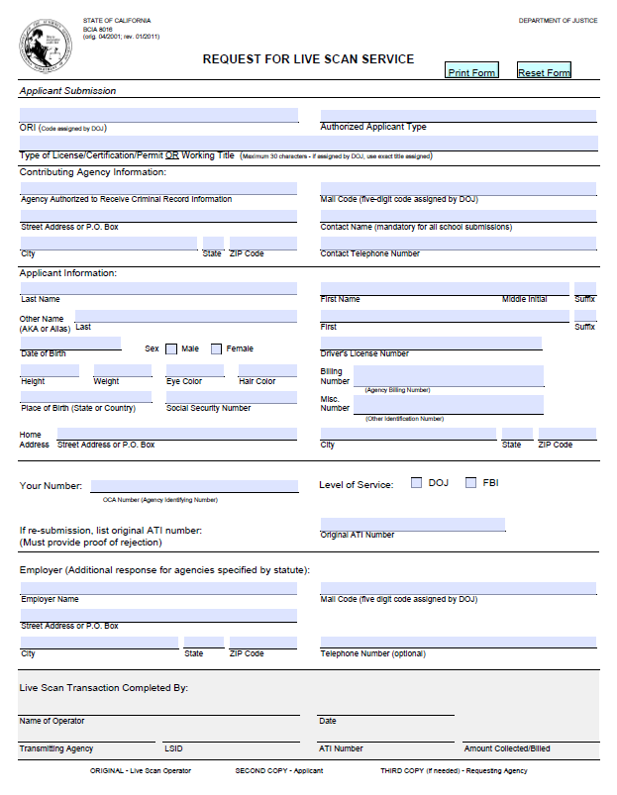

Attachment D
NAME OF AGENCY Volunteer Job Description

Department/Division/Program:
Position Title: Reports to:

This Position Requires: Driver license Background check Fingerprinting
Use of NAME OF AGENCY vehicles to perform task
Use of private vehicle to perform task

Purpose/Goal of Position:

Qualifications/Skills/Certifications Needed:

Duties/Responsibilities:

Time Commitment:
Length (months): # Hours per day:
# Days per week: Or month:

Training Provided:

Worksite Name/Location:
Phone:

Contact for More Information:
Phone:

______________________________________________________ ___________________
(Volunteer Signature) (Date)
______________________________________________________ ___________________
(Supervisor Signature) (Date)

Attachment E

NAME OF AGENCY Volunteer Job Risk Assessment

Volunteer Job/Task: _______________________________ Department: _____________________
Work Location: __________________________________ Assessment Date: _________________
Driver License Required? Yes No Ability to Lift 25 lbs. Repeatedly? Yes No
Minimum Age (specify): ______________

Check left column to show potential hazards of this volunteer position
Outdoor Hazard Source |  | Personal Protection Required | Necessary Training
 | Bites: snakes, dogs, insects | Protective clothing, footwear, gloves | Hazard specific training
 | Heat Stress: heat stroke, exhaustion, or dehydration | Ventilation, heat resistant clothing, water to replenish lost fluids | Recognition of heat stress signs
 | Sun Exposure: skin cancer or vision damage | Sunscreen, brimmed hat, ultraviolet eye protection and protective clothing | Sun hazard awareness
 | Driving: injury to vehicle occupants from collision | Seat belts | Defensive driving
 | Traffic: injury to workers from motor vehicle traffic or heavy equipment | Proper footwear, hard hat or eye protection, orange safety vest, traffic cones, signs and flares | Traffic control, working around heavy equipment
Indoor Hazard Source |  | Personal Protection Required | Necessary Training
 | Office Equipment: paper cutters, shredders, file cabinets, computer screens or keyboards | Proper footwear and clothing for office | Safe operations specific to equipment, RMI prevention
Indoor or Outdoor Hazard Source |  | Personal Protection Required | Necessary Training
 | Hand Tools: powered or unpowered | Proper footwear, clothing and eye protection | Safe hand tool use, RMI prevention
 | Footing Traction: slippery, uneven or unstable walking surfaces/terrain | Proper footwear | Slips, trips and falls protection
 | Ladders: freestanding or fixed | Proper footwear, safety tie offs, bracing | Ladder safety
 | Elevated work surfaces: falls from height | Fall protection, proper footwear | Slips, trips and falls
 | Noise: noise from machinery/equipment | Hearing protection | Hearing conservation
 | Body Position/Leverage: strenuous or repetitive lifting, carrying or pulling | Back brace, lifting and carrying aids such as hand trucks, dollies or slings | Safe lifting and carrying, back safety awareness
Regulated Hazard Source |  | Personal Protection Required | Necessary Training
 | Chemicals: gases, vapors or liquids that when inhaled, ingested or touched can cause injury of illness | Protective clothing, gloves, glasses/goggles, if indicated, appropriate respirator | SDS, fire extinguisher, chemical specific handling, hazardous materials training
 | Bio-waste: bodily fluids or OPIM | Gloves, face and eye protection | Bloodborne pathogen training

Additional Hazards: ____________________________________________________________________
______________________________________________________ ___________________
(Volunteer Signature) (Date)
______________________________________________________ ___________________
(Supervisor Signature) (Date)

Attachment F
NAME OF AGENCY
VOLUNTEER SERVICE AGREEMENT

I ________________________________ agree to serve as _________________________.
(Name of Volunteer) (Title of Job – Job Description Attached)

I understand my volunteer services will start on ____________ and are anticipated to last until ______________.
(Anticipated Termination Date)

My schedule will be: ______________________ from ___________ to ___________.
(day/s of week) (Time) (Time)

I understand the NAME OF AGENCY has the right to release me from service prior to the anticipated service termination date.

I further understand failure to adhere to the NAME OF AGENCY’s policies and procedures may result in immediate release from volunteer service.

As a volunteer for the NAME OF AGENCY, I agree to:

- Perform the duties as specified in the attached volunteer job description.
- Report to work on time and as scheduled.
- Immediately notify my supervisor if I am unable to meet my shift commitment.
- Immediately report to my supervisor volunteer work-related injuries and illnesses.
- Immediately report to my supervisor any safety concerns or observed unsafe conditions/behaviors.
- Follow the instructions provided by my supervisor.
- Perform my duties in a respectful and appropriate manner.
- Refrain from horseplay.
- Adhere to the NAME OF AGENCY’s policies and procedures.
- Maintain confidentiality.
- Attend all required training.
- Give adequate notice before terminating my volunteer services.
- _____________________________________________________________________

- _____________________________________________________________________

Signed: __________________________________________ Date: _____________________
(Volunteer)

Signed: __________________________________________ Date: _____________________
(Parent/Guardian)

Signed: __________________________________________ Date: _____________________
(NAME OF AGENCY Representative)

Attachment G
EMERGENCY CONTACT FORM
FOR VOLUNTEERS

List two people to notify in the case of an emergency. For volunteers under the age of 18 years, list at least one parent/guardian as one of the two emergency contact people.

Name: ___________________________ Relationship: _______________________________
Address: ____________________________________________________________________
City: ___________________ State: ______________ Zip Code: _______________________
Phone: (H): _______________________________ (W) _______________________________
(M) _______________________________

Name: ___________________________ Relationship: _______________________________
Address: ____________________________________________________________________
City: ___________________ State: ______________ Zip Code: _______________________
Phone: (H): _______________________________ (W) _______________________________
(M) _______________________________

Attachment H
California Department of Motor Vehicles – Employer Pull Notice Program
Authorization for Release of Driver Record Information

DMV Form INF 1101
PDF fillable form available at
https://www.dmv.ca.gov/portal/dmv/detail/vehindustry/epn/epnformlist

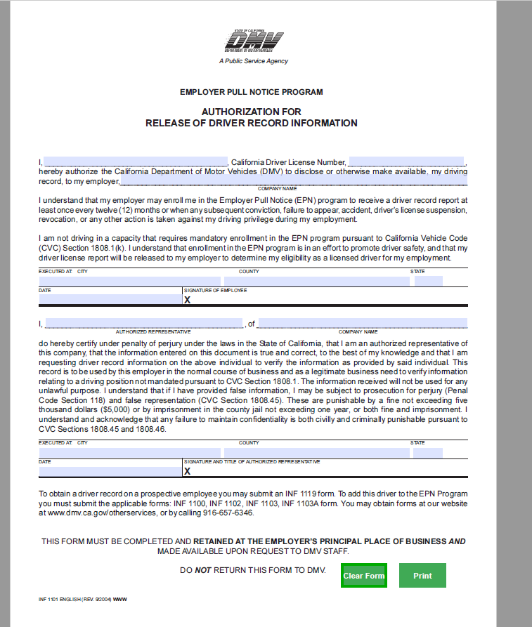
Attachment I

NAME OF AGENCY Volunteer Monthly Report

Department Name: _____________________________________
Department Head: _____________________________________
Month/Year of Report: _____________________________________

Complete for all department volunteers:
Name: _____________________________________ Hours Volunteered: ____________
Name: _____________________________________ Hours Volunteered: ____________
Name: _____________________________________ Hours Volunteered: ____________
Name: _____________________________________ Hours Volunteered: ____________
Name: _____________________________________ Hours Volunteered: ____________
Name: _____________________________________ Hours Volunteered: ____________
Name: _____________________________________ Hours Volunteered: ____________
Name: _____________________________________ Hours Volunteered: ____________
Name: _____________________________________ Hours Volunteered: ____________
Name: _____________________________________ Hours Volunteered: ____________
Name: _____________________________________ Hours Volunteered: ____________
Total: ____________

Volunteers new to the department for the month of ____________________
Name: _____________________________________
Name: _____________________________________
Name: _____________________________________

Volunteers leaving the department for the month of ____________________
Name: _____________________________________
Name: _____________________________________
Name: _____________________________________

________________________________________________________________________ ___________________
Department Head Signature Date

